UNIVERSIDADE FEDERAL DO RIO GRANDE DO SUL

INSTITUTO DE INFORMATICA

Aula 31/1/23 - Sistemas Digitais

Prof. Fernanda Kastensmit

**Objetivo:** projetar e descrever em VHDL o processador Ahmes, implementar 2 programas em sua memória e mostrar através de simulação lógica sem e com atraso o funcionamento.

**AULA 3 (31/1/2022)**

Descrever a parte de controle do AHMES em VHDL como uma maquina de estados.

**Passo 1:** Dada as tabelas com as instruções do Neander por estado da máquina de estrados

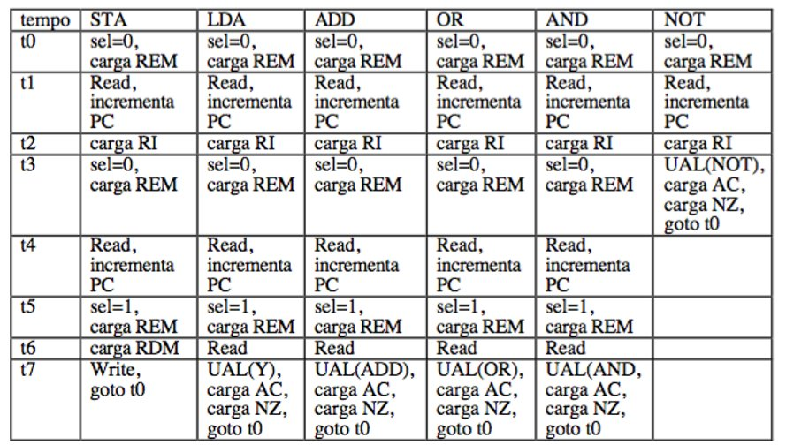

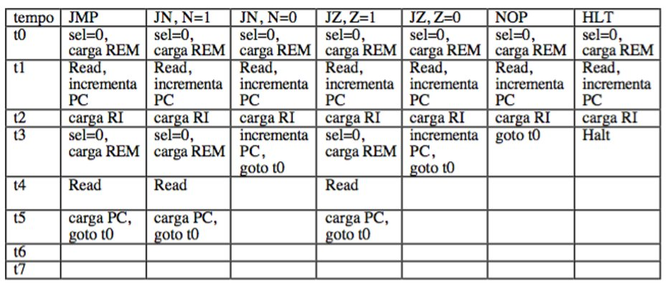

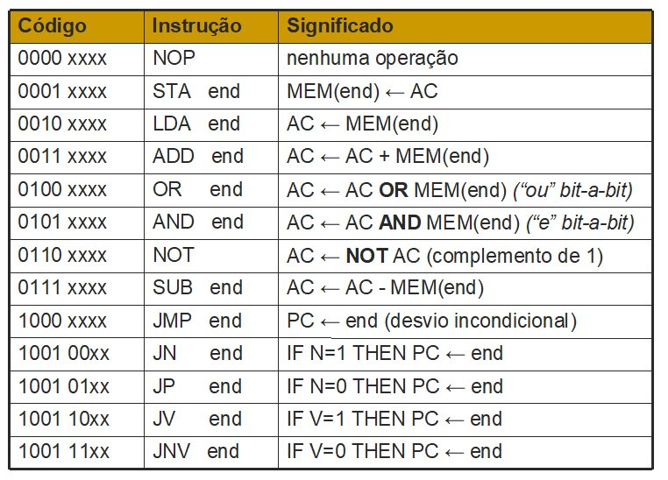

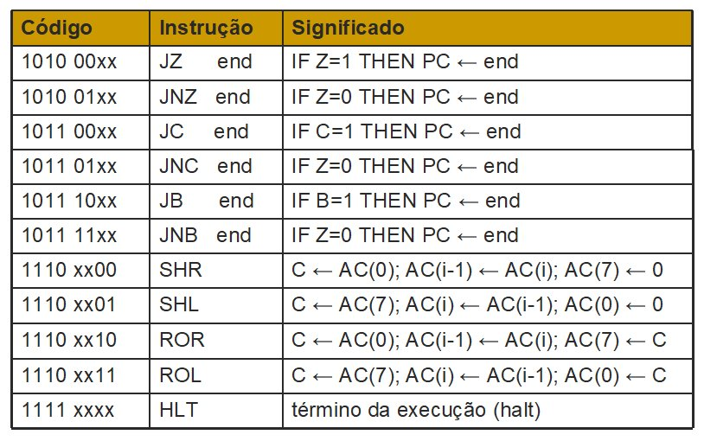

Completar a tabela a seguir com as instruções AHMES que não tem no NEANDER e as instruções novas de Desvio

| Tempo | SHR | SHL | ROR | ROL | SUB | **JV, V=1** | **JNV, V=0** |
| --- | --- | --- | --- | --- | --- | --- | --- |
| T0 | sel = 0,  load REM | Sel = 0,  load REM | Sel = 0,  load REM | Sel = 0,  load REM | Sel = 0,  load REM | Sel = 0,  load REM | Sel = 0,  load REM |
| T1 | Read,  Inc PC | Read,  Inc PC | Read,  Inc PC | Read,  Inc PC | Read,  Inc PC | Read,  Inc PC | Read,  Inc PC |
| T2 | load RI | load RI | load RI | load RI | Load RI | Load RI | Load RI |
| T3 | ULA(SHR),  load AC,  load flags,  Goto t0 | ULA(SHL),  load AC,  load flags,  Goto t0 | ULA(ROR),  load AC,  load flags,  Goto t0 | ULA(ROL),  load AC,  load flags,  Goto t0 | Sel = 0,  Load REM | Sel = 0,  Load REM | Sel = 0,  Load REM |
| T4 |  |  |  |  | Read,  Inc PC | Read | Read |
| T5 |  |  |  |  | Sel = 1,  Load REM | Load PC,  Goto t0 | Load PC,  Goto t0 |
| T6 |  |  |  |  | Read |  |  |
| T7 |  |  |  |  | ULA(SUB), load AC,  Load NZBC |  |  |

| Tempo | **JNZ, Z=0** | **JP, Z=0** | **JC, C=1** | **JNC, C=0** | **JB, B=1** | **JNB, B=1** |  |
| --- | --- | --- | --- | --- | --- | --- | --- |
| T0 | Sel = 0,  load REM | Sel = 0,  load REM | Sel = 0,  load REM | Sel = 0,  load REM | Sel = 0,  load REM | Sel = 0,  load REM |  |
| T1 | Read,  Inc PC | Read,  Inc PC | Read,  Inc PC | Read,  Inc PC | Read,  Inc PC | Read,  Inc PC |  |
| T2 | Load RI | Load RI | Load RI | Load RI | Load RI | Load RI |  |
| T3 | Sel = 0,  Load REM | Sel = 0,  Load REM | Sel = 0,  Load REM | Sel = 0,  Load REM | Sel = 0,  Load REM | Sel = 0,  Load REM |  |
| T4 | Read | Read | Read | Read | Read | Read |  |
| T5 | Load PC,  Goto t0 | Load PC,  Goto t0 | Load PC,  Goto t0 | Load PC,  Goto t0 | Load PC,  Goto t0 | Load PC,  Goto t0 |  |
| T6 |  |  |  |  |  |  |  |
| T7 |  |  |  |  |  |  |  |

*library IEEE;*

*use IEEE.STD_LOGIC_1164.ALL;*

*use IEEE.NUMERIC_STD.ALL;*

*entity control_ahmes is*

*Port(*

*CLOCK: in std_logic;*

*RESET: in std_logic;*

*-- controle dos registradores*

*inc_pc: out std_logic;*

*load_ac: out std_logic;*

*load_pc: out std_logic;*

*load_REM: out std_logic;*

*load_RDM: out std_logic;*

*load_RI: out std_logic;*

*load_N: out std_logic;*

*load_Z: out std_logic;*

*load_V: out std_logic;*

*load_C: out std_logic;*

*load_B: out std_logic;*

*-- seletores*

*sel_ULA: out std_logic_vector(3 downto 0);*

*sel_MUXREM: out std_logic;*

*sel_MUXRDM: out std_logic;*

*-- controle da memoria*

*--mem_read: out std_logic; -- nao utilizado*

*mem_write: out std_logic;*

*-- flags de estado*

*reg_N: in STD_LOGIC;*

*reg_Z: in STD_LOGIC;*

*reg_V: in STD_LOGIC;*

*reg_C: in STD_LOGIC;*

*reg_B: in STD_LOGIC;*

*-- flags das operacoes*

*op_nop: in std_logic;*

*op_sta: in std_logic;*

*op_lda: in std_logic;*

*op_add: in std_logic;*

*op_or: in std_logic;*

*op_and: in std_logic;*

*op_not: in std_logic;*

*op_sub: in std_logic;*

*op_jmp: in std_logic;*

*op_jn: in std_logic;*

*op_jp: in std_logic;*

*op_jv: in std_logic;*

*op_jnv: in std_logic;*

*op_jz: in std_logic;*

*op_jnz: in std_logic;*

*op_jc: in std_logic;*

*op_jnc: in std_logic;*

*op_jb: in std_logic;*

*op_jnb: in std_logic;*

*op_shr: in std_logic;*

*op_shl: in std_logic;*

*op_ror: in std_logic;*

*op_rol: in std_logic;*

*op_hlt: in std_logic);*

*end control_ahmes;*

*architecture Behavioral of control_ahmes is*

*type state_type is (S0, S1, S2, S3, S4, S5, S6, S7, S8);*

*signal next_state, current_state: state_type;*

*begin*

*process(CLOCK, RESET) -- controle de estados*

*begin*

*if(RESET = '1') then*

*current_state <= S0;*

*elsif(rising_edge(CLOCK)) then*

*current_state <= next_state;*

*else*

*current_state <= current_state;*

*end if;*

*end process;*

*process(*

*next_state,*

*-- flags gerais*

*reg_N,*

*reg_Z,*

*reg_V,*

*reg_C,*

*reg_B,*

*--flags das ops*

*op_nop,*

*op_sta,*

*op_lda,*

*op_add,*

*op_or,*

*op_and,*

*op_not,*

*op_sub,*

*op_jmp,*

*op_jn,*

*op_jp,*

*op_jv,*

*op_jnv,*

*op_jz,*

*op_jnz,*

*op_jc,*

*op_jnc,*

*op_jb,*

*op_jnb,*

*op_shr,*

*op_shl,*

*op_ror,*

*op_rol,*

*op_hlt)*

*begin*

*-- reseta sinais de carga*

*inc_pc <= '0';*

*load_ac <= '0';*

*load_pc <= '0';*

*load_N <= '0';*

*load_Z <= '0';*

*load_V <= '0';*

*load_C <= '0';*

*load_B <= '0';*

*load_RDM <= '0';*

*load_REM <= '0';*

*sel_MUXREM <= '0';*

*sel_MUXRDM <= '0';*

*sel_ULA <= "0000";*

*mem_write <= '0';*

*case current_state is*

*when S0 =>*

*load_RDM <= '1';*

*next_state <= S1;*

*when S1 =>*

*load_REM <= '0';*

*inc_pc <= '0';*

*next_state <= S2;*

*when S2 =>*

*load_RDM <= '1';*

*inc_pc <= '1';*

*next_state <= S3;*

*when S3 =>*

*inc_pc <= '0';*

*load_RDM <= '0';*

*if(op_nop = '1') then -- NOP*

*next_state <= S0;*

*elsif(op_not = '1') then -- NOT*

*sel_ULA <= "0011";*

*load_AC <= '1';*

*load_N <= '1';*

*load_Z <= '1';*

*load_V <= '1';*

*load_C <= '1';*

*load_B <= '1';*

*next_state <= S0;*

*elsif(op_jn = '1' and reg_N = '0') then -- JN quando n=0*

*inc_PC <= '1';*

*next_state <= S0;*

*elsif(op_jp = '1' and reg_N = '1') then -- JP quando n=1*

*inc_PC <= '1';*

*next_state <= S0;*

*elsif(op_jv = '1' and reg_V = '0') then -- JV quando v=0*

*inc_PC <= '1';*

*next_state <= S0;*

*elsif(op_jv = '1' and reg_V = '1') then -- JNV quando v=1*

*inc_PC <= '1';*

*next_state <= S0;*

*elsif(op_jz = '1' and reg_Z = '0') then -- JZ quando z=0*

*inc_PC <= '1';*

*next_state <= S0;*

*elsif(op_jz = '1' and reg_Z = '1') then -- JNZ quando z=1*

*inc_PC <= '1';*

*next_state <= S0;*

*elsif(op_jc = '1' and reg_C = '0') then -- JC quando c=0*

*inc_PC <= '1';*

*next_state <= S0;*

*elsif(op_jb = '1' and reg_C = '1') then -- JNC quando c=1*

*inc_PC <= '1';*

*next_state <= S0;*

*elsif(op_jb = '1' and reg_B = '0') then -- JB quando b=0*

*inc_PC <= '1';*

*next_state <= S0;*

*elsif(op_jb = '1' and reg_B = '1') then -- JNB quando b=1*

*inc_PC <= '1';*

*next_state <= S0;*

*elsif(op_shr = '1') then -- SHR*

*sel_ULA <= "0101";*

*load_AC <= '1';*

*load_N <= '1';*

*load_Z <= '1';*

*load_V <= '1';*

*load_C <= '1';*

*load_B <= '1';*

*next_state <= S0;*

*elsif(op_shr = '1') then -- SHL*

*sel_ULA <= "0101";*

*load_AC <= '1';*

*load_N <= '1';*

*load_Z <= '1';*

*load_V <= '1';*

*load_C <= '1';*

*load_B <= '1';*

*next_state <= S0;*

*elsif(op_shr = '1') then -- ROR*

*sel_ULA <= "0101";*

*load_AC <= '1';*

*load_N <= '1';*

*load_Z <= '1';*

*load_V <= '1';*

*load_C <= '1';*

*load_B <= '1';*

*next_state <= S0;*

*elsif(op_shr = '1') then -- ROL*

*sel_ULA <= "0101";*

*load_AC <= '1';*

*load_N <= '1';*

*load_Z <= '1';*

*load_V <= '1';*

*load_C <= '1';*

*load_B <= '1';*

*next_state <= S0;*

*elsif(op_hlt = '1') then -- HLT*

*inc_PC <= '0';*

*next_state <= S8;*

*else -- qualquer outra operacao*

*sel_MUXREM <= '0';*

*load_REM <= '1';*

*next_state <= S4;*

*end if;*

*when S4 =>*

*sel_MUXREM <= '0';*

*inc_PC <= '0';*

*load_AC <= '0';*

*load_REM <= '0';*

*load_AC <= '0';*

*load_N <= '0';*

*load_Z <= '0';*

*load_V <= '0';*

*load_C <= '0';*

*load_B <= '0';*

*if(op_sta = '1' or*

*op_lda = '1' or*

*op_add = '1' or*

*op_or = '1' or*

*op_and = '1' or*

*op_sub = '1' or*

*op_jmp = '1' or*

*op_jn = '1' or*

*op_jp = '1' or*

*op_jv = '1' or*

*op_jnv = '1' or*

*op_jz = '1' or*

*op_jnz = '1' or*

*op_jc = '1' or*

*op_jnc = '1' or*

*op_jb = '1' or*

*op_jnb = '1') then*

*inc_PC <= '1';*

*end if;*

*next_state <= S5;*

*when S5 =>*

*inc_PC <= '0';*

*if(op_sta = '1' or*

*op_lda = '1' or*

*op_add = '1' or*

*op_or = '1' or*

*op_and = '1' or*

*op_sub = '1' or*

*op_jmp = '1' or*

*op_jn = '1' or*

*op_jp = '1' or*

*op_jv = '1' or*

*op_jnv = '1' or*

*op_jz = '1' or*

*op_jnz = '1' or*

*op_jc = '1' or*

*op_jnc = '1' or*

*op_jb = '1' or*

*op_jnb = '1') then*

*sel_MUXREM <= '1';*

*load_REM <= '1';*

*next_state <= S6;*

*else*

*load_PC <= '1';*

*next_state <= S0;*

*end if;*

*when S6 =>*

*inc_PC <= '0';*

*sel_MUXREM <= '0';*

*load_REM <= '0';*

*load_PC <= '0';*

*next_state <= S7;*

*if(op_sta = '1') then -- STA*

*load_RDM <= '1';*

*end if;*

*when S7 =>*

*if(op_sta = '1') then*

*mem_write <= '1';*

*elsif(op_lda = '1') then*

*sel_ULA <= "0100"; -- NOP(ULA Y)*

*elsif(op_add = '1') then*

*sel_ULA <= "0000";*

*elsif(op_or = '1') then*

*sel_ULA <= "0001";*

*elsif(op_and = '1') then*

*sel_ULA <= "0010";*

*elsif(op_not = '1') then*

*sel_ULA <= "0011";*

*elsif(op_sub = '1') then*

*sel_ULA <= "0100";*

*end if;*

*when S8 =>*

*next_state <= S8;*

*when others =>*

*next_state <= S0;*

*end case;*

*end process;*

*end Behavioral;*

**\*\*\*ENTREGAR DIA 03/2/2023**** Editando esse DOC e submetendo no MS-TEAMS**